DATA VISUALIZATION USING PYTHON
MATPLOTLIB AND SEABORN

INTRODUCTION TO DATA VISUALIZATION
Data visualization is the graphical representation of data and information using charts, graphs, and plots. It converts raw numerical data into a visual form, making it easier to understand patterns, trends, and relationships. Visualization plays a crucial role in data analysis as it helps users interpret large and complex datasets efficiently.
In today’s data-driven world, organizations generate enormous volumes of data daily. Analysing such data using only tables or numbers is difficult and time-consuming. Visualization simplifies this process by presenting insights in a clear and intuitive manner. Python has emerged as one of the most popular languages for data visualization due to its simplicity and powerful libraries.

IMPORTANCE OF DATA VISUALIZATION
Data visualization improves understanding and communication. Humans can process visual information faster than textual information, making charts and graphs highly effective. Visualization helps in identifying trends, detecting anomalies, comparing categories, and making informed decisions.
Visualization is widely used in business analytics, healthcare, finance, education, and scientific research. It also plays an important role in machine learning by helping analyse data distributions and model performance.

PYTHON VISUALIZATION LIBRARIES
Python provides several visualization libraries such as Matplotlib, Seaborn, Plotly, Bokeh, and Pandas visualization. Among these, Matplotlib and Seaborn are the most widely used and form the foundation for learning visualization concepts. This documentation focuses on Matplotlib and Seaborn.

INTRODUCTION TO MATPLOTLIB
Matplotlib is a low-level visualization library used to create static plots in Python. It offers complete control over plot elements, making it suitable for detailed and customized visualizations. It supports a wide range of plot types including line plots, bar charts, histograms, scatter plots, pie charts, and area charts.
MATPLOTLIB ARCHITECTURE
Matplotlib follows an object-oriented design.
- Figure is the main container.
- Axes represent individual plots.
- Axis controls scales and ticks.
- Artists include all visible elements such as lines, text, and shapes.
Understanding this structure helps in creating advanced plots.

THE PYPLOT MODULE
The Pyplot module provides a simple interface for plotting.
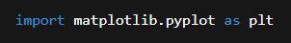
Pyplot automatically handles figure creation and axis management, making it beginner-friendly.

LINE PLOT
Line plots are one of the most basic and commonly used types of charts. A line plot connects data points using straight lines and is useful for showing trends over continuous data.
Line plots are widely used in:
- Time-series analysis
- Performance tracking
- Scientific experiments
Matplotlib allows plotting multiple lines on the same graph, making it easy to compare trends. Line colour, width, and style can also be customized.
Code
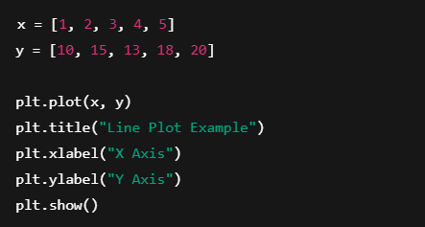
Code Description
The plot () function draws a line graph using x and y values. Titles and axis labels improve readability, and show () displays the graph.
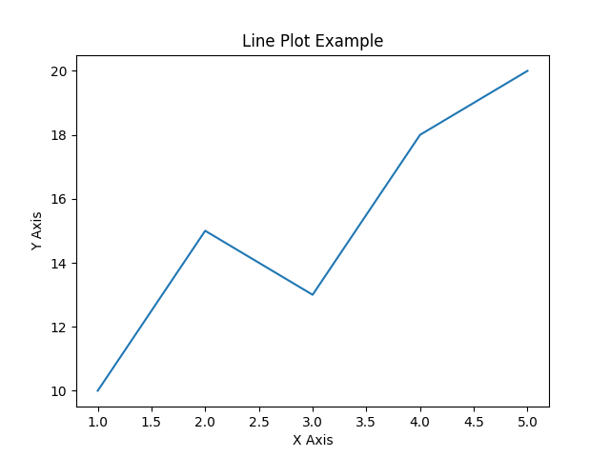
Visualization Description
The line plot shows how values change over a continuous range. It is useful for identifying upward or downward trends.

MULTIPLE LINE PLOT (MATPLOTLIB)
Code
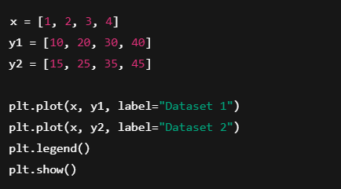
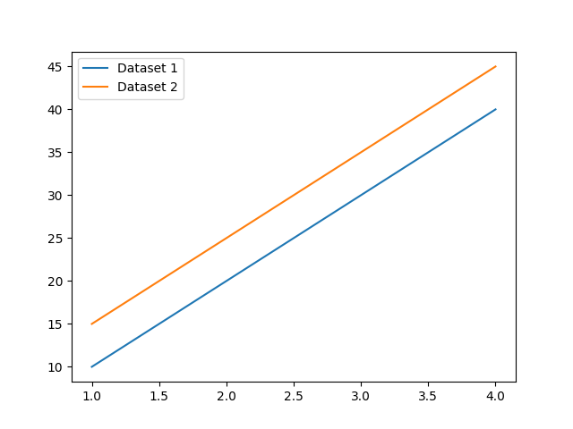
Visualization Description
Multiple line plots allow comparison of trends between datasets on the same axes.

BAR CHART (MATPLOTLIB)
Bar charts represent categorical data using rectangular bars. The length or height of each bar corresponds to the value of the category.
Bar charts are useful for:
- Comparing quantities across categories
- Displaying frequency counts
- Visualizing survey results
Matplotlib supports vertical, horizontal, and grouped bar charts. Bar colours, widths, and labels can be customized to improve readability.
Code
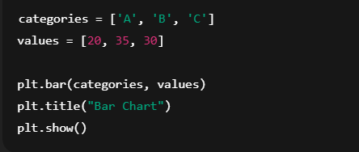
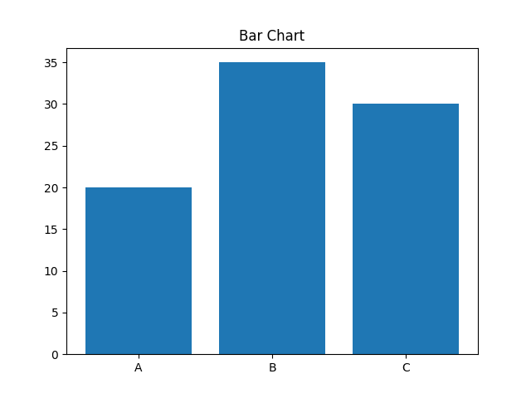
Visualization Description
Bar charts compare values across categories. Taller bars indicate higher values.

HISTOGRAM (MATPLOTLIB)
Histograms are used to display the distribution of numerical data. The data is divided into bins, and the frequency of values in each bin is displayed as bars.
Histograms help answer questions such as:
- How is data distributed?
- Is the data skewed?
- Are there any outliers?
Histograms are commonly used in statistics, probability, and data analysis tasks.
Code
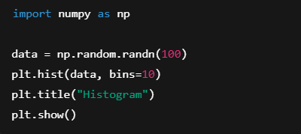
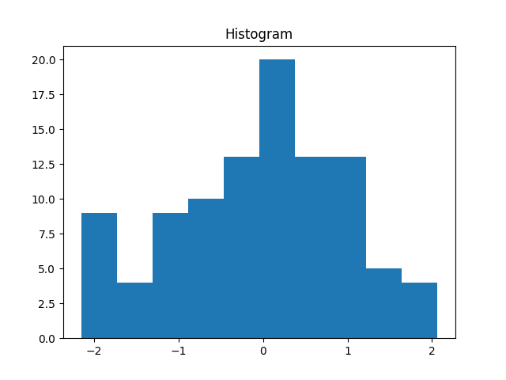

Visualization Description
Histograms display frequency distribution of numerical data, helping understand data spread and skewness.
SCATTER PLOT (MATPLOTLIB)
Scatter plots use points to represent the relationship between two numerical variables. Each point corresponds to one observation.
Scatter plots are useful for:
- Identifying correlations
- Detecting clusters
- Finding outliers
Matplotlib allows scatter plots with different colours, sizes, and markers, making it easy to visualize multiple datasets in a single plot.
Code
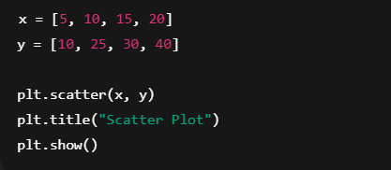
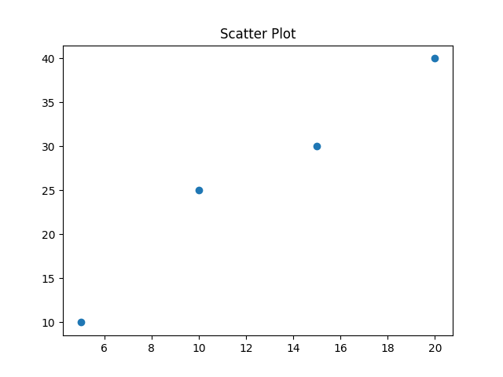
Visualization Description
Scatter plots show relationships between two variables and help identify correlation or outliers.
PIE CHART AND AREA CHART
Pie charts represent proportions of a whole. Each slice shows the percentage contribution of a category. Pie charts are best used when there are a small number of categories.
Area charts show quantitative data over time and emphasize magnitude by filling the area under the line. They are useful for showing cumulative values and trends.
Pie Chart Code
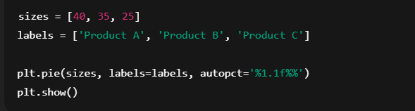
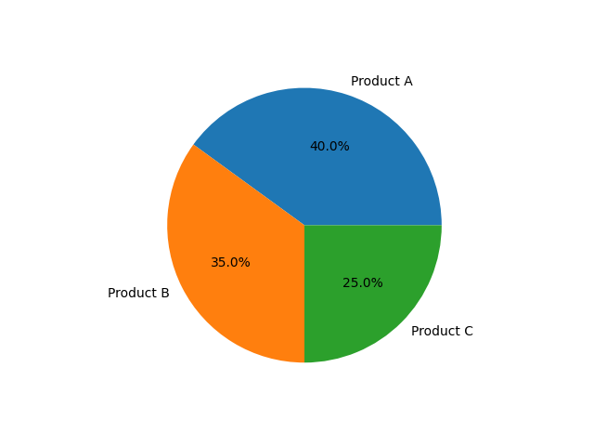
Visualization Description
Pie charts represent proportions of a whole using slices.

Area Chart Code
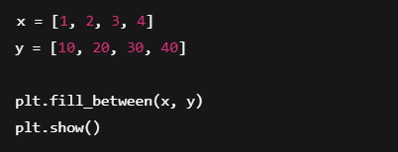
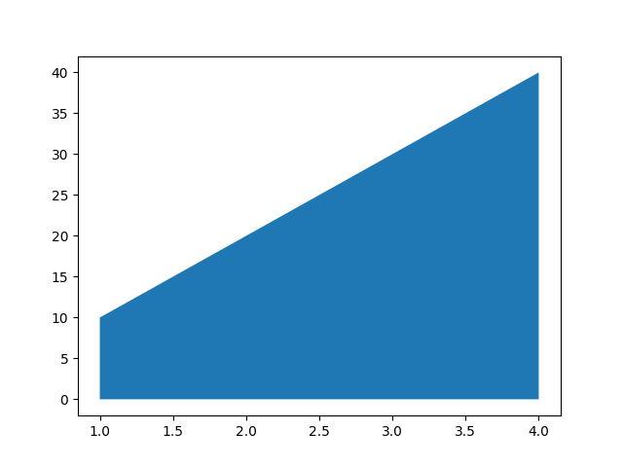

Visualization Description
Area charts emphasize magnitude by filling the area under a line.

CUSTOMIZATION IN MATPLOTLIB
One of Matplotlib’s biggest strengths is customization. Users can modify:
- Titles
- Axis labels
- Legends
- colours
- Grid lines
- Font styles
Matplotlib also supports subplots, which allow multiple plots to be displayed within the same figure. This is useful for comparative analysis.
Code
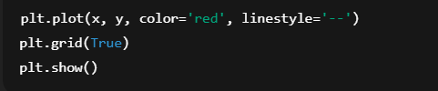
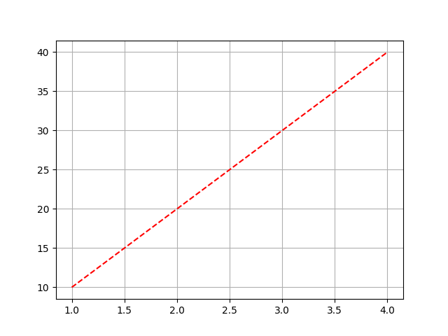
Visualization Description
Customization improves clarity and presentation, making plots suitable for reports.
INTRODUCTION TO SEABORN
Seaborn is a Python visualization library built on top of Matplotlib. It provides a higher-level interface for creating attractive and informative statistical graphics.
Seaborn focuses on simplifying complex plotting tasks and provides visually appealing default styles. It is especially useful for exploratory data analysis.
Seaborn integrates seamlessly with Pandas Data Frames, allowing users to plot data directly from structured datasets.
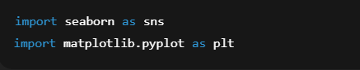
CATEGORIES OF SEABORN PLOTS
Seaborn organizes plots into categories:
- Relational plots
- Categorical plots
- Distribution plots
- Regression plots
- Matrix plots
This classification helps users choose the appropriate plot type based on the nature of the data.
RELATIONAL PLOTS (SEABORN)
Relational plots are used to visualize relationships between variables. Common relational plots include scatter plots and line plots.
Seaborn allows grouping using parameters such as colour and style, making it easier to compare subgroups within data.

Scatter Plot Code
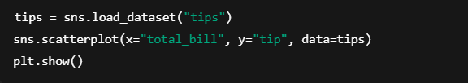
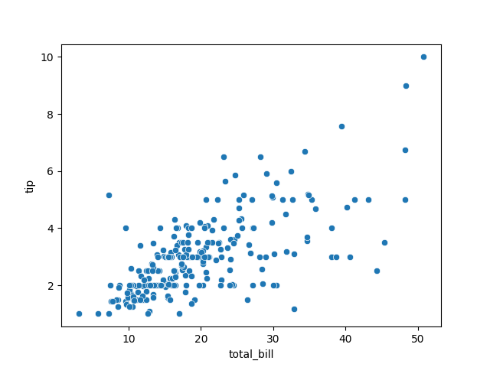

Visualization Description
This plot shows relationships between numerical variables with clean styling.

Line Plot Code
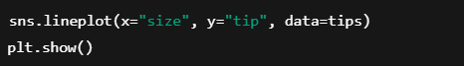
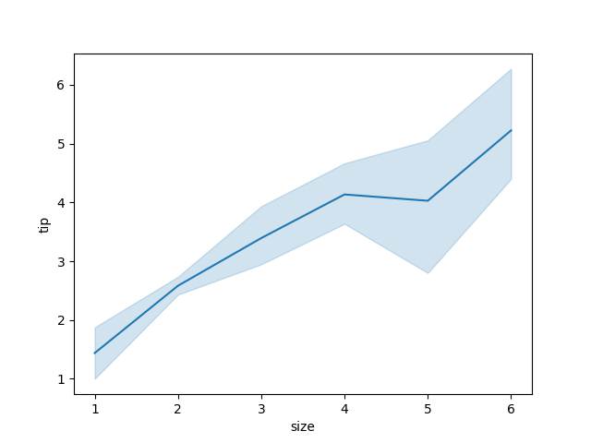
Visualization Description
Line plots show trends with smooth lines and confidence intervals.

CATEGORICAL PLOTS (SEABORN)
Categorical plots compare values across categories. These include bar plots, count plots, box plots, and violin plots.
Categorical plots are useful for analysing differences between groups and understanding data distributions within categories.

Bar Plot
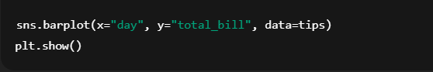
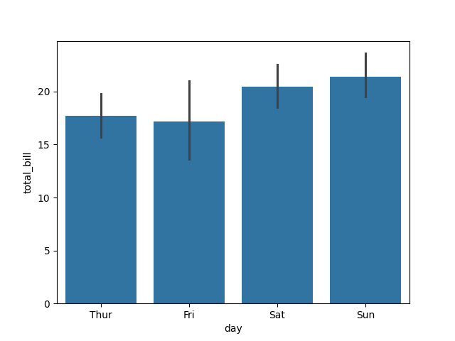
Count Plot
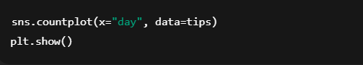
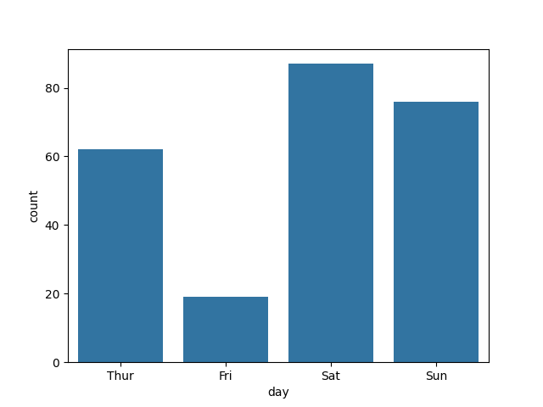
Visualization Description
Categorical plots compare values across categories and show frequencies.
BOX PLOT AND VIOLIN PLOT
Code
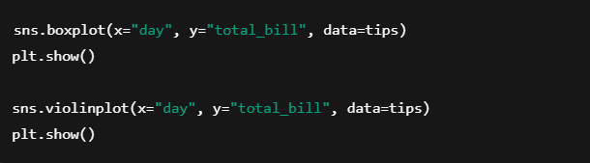
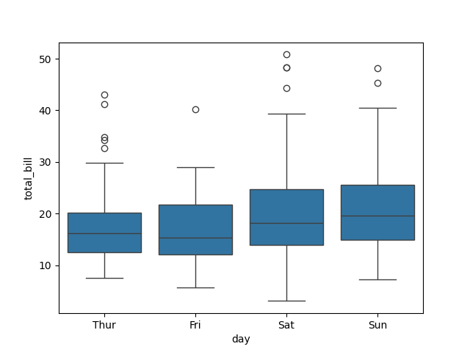
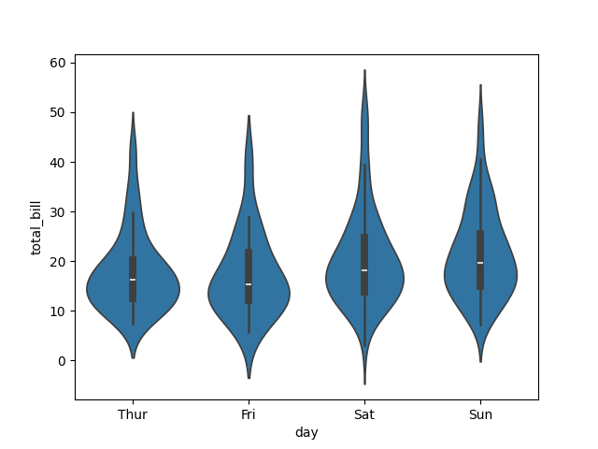
Visualization Description
Box plots show quartiles and outliers, while violin plots show data density and distribution shape.
DISTRIBUTION PLOTS (SEABORN)
Distribution plots show how data values are distributed. Seaborn provides histograms, density plots, and rug plots. Kernel Density Estimation (KDE) plots show a smooth curve representing data probability density.
Code
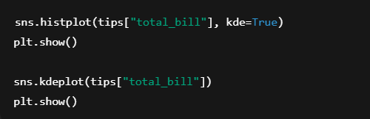
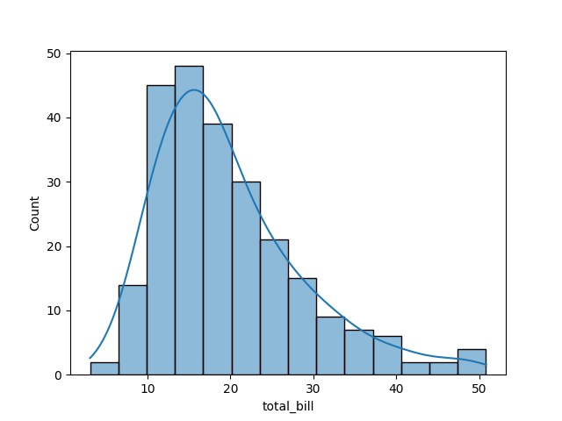
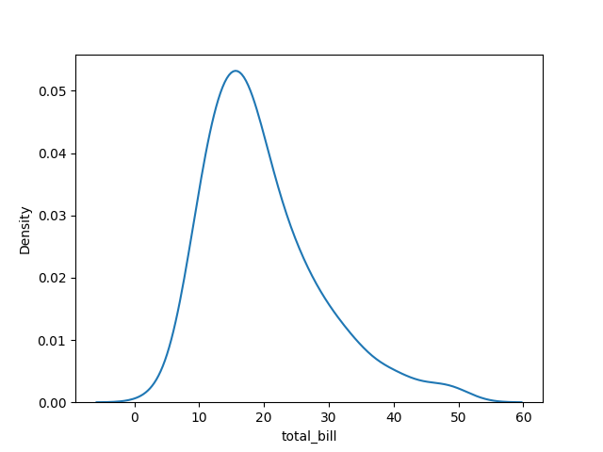
Visualization Description
Distribution plots help understand frequency and probability density of data.

HEATMAP AND REGRESSION PLOT
Regression plots show the relationship between variables along with a regression line. These plots help understand trends and predictions.
Matrix plots such as heatmaps visualize data matrices using colour gradients. Heatmaps are commonly used for correlation analysis.
Heatmap Code
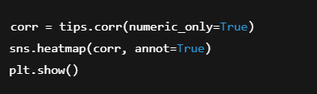
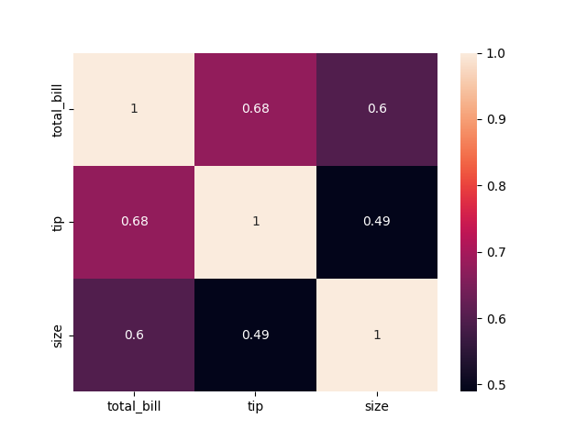
Visualization Description
Heatmaps visualize correlation values using colour gradients.

Regression Plot Code
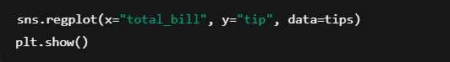
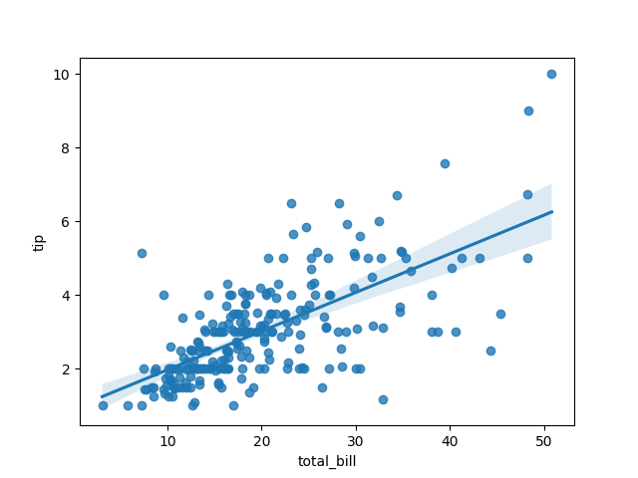

Visualization Description
Regression plots show relationships along with a best-fit line.

COMPARISON AND CONCLUSION
Comparison
Matplotlib provides low-level control and extensive customization, making it ideal for detailed and precise plots. However, it requires more code.
Seaborn offers simplicity and attractive default styles, making it ideal for quick statistical visualization. It is easier for beginners.
Both libraries complement each other and are often used together.

Feature | Matplotlib | Seaborn
Ease of Use | Moderate | Easy
Customization | High | Medium
Default Styling | Basic | Attractive
Statistical Plots | Limited | Extensive

Conclusion
Data visualization is an essential part of data analysis and decision-making. Python provides powerful libraries for visualization, among which Matplotlib and Seaborn are the most widely used.
Matplotlib offers flexibility and control, while Seaborn provides simplicity and statistical capabilities. By learning both libraries, beginners can create effective and meaningful visualizations for a wide range of applications.

